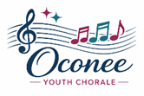
Oconee Youth Chorale
Advanced Ladies Audition Guide - 2026-2027


Hello! I’m John Fallon, and I have the joy of being the director of the Treble Choir (SSA) Oconee Youth Chorale ensemble.

The goal in the audition process is for me to learn about you as a human being, to learn about your musical background, and place you in the ensemble and voice part that will best serve your growth. No matter the ensemble you are placed in, we will work passionately to provide you with an incredible experience this upcoming year. Most importantly, know that during the audition, I’m here to support you and cheer you on. :)

Important steps…

- Click here to sign up for an audition time (if you haven’t done so already)
- Complete the (Click here) the OYC School Info Form (due before your audition)
- Read the info below to prepare for the audition and to learn what to expect

QUICK AUDITION OVERVIEW

The audition will consist of…

- Vocalizations (I’ll lead you through these with the piano)
- Tonal Memory (I’ll play a few notes, you’ll sing them back)
- Rhythmic Sight Reading (You’ll sight-read a rhythm)
- Melodic Sight Reading (You’ll sight-read a melody)
- Sing Something of Your Choice (30-60 second excerpt, any style)

IN-DEPTH AUDITION OVERVIEW

The audition consists of several parts. Please read the steps below so you know what to expect. There are resources listed and linked below to help you practice each component of the audition.

When you enter the room for your audition, you can expect to see me smiling and joyfully greeting you. I’ll have you sit, and we’ll chat for about a minute – nothing to prepare for that! This time allows me to learn a bit about you as a person. Expect questions like “how is your year going?” or if you’re new, “what’s your high school?” etc. I may also reference a few of the answers you’ve submitted in the (Click Here) OYC School Info Form so again, make sure to have that completed before your audition time.

There are five (5) parts of the audition:

- Vocalizations (~2 minutes)

I’ll then have you stand up, and I will lead you through a series of vocalizations from the piano. For this, I’m listening for and learning about your tone (e.g., vocal technique, vibrancy, resonance, vowel shape, register management, free and unpressured sound, soloistic quality, etc), intonation (i.e., how well you sing in-tune), and your range. Below, I’ve linked some supportive piano tracks so you can hear exactly how each vocalization will be played.

NOTE: Your audition won't be exactly like the tracks below, since I’ll only take you to the extremes of your range, so you may end up singing less or more than heard in the piano tracks. Also, I’ll sometimes shift up or down by a half step or whole step, so just follow along with whatever I play. Here are the three (3) exercises you’ll do:

- Descending, 54321 (So Fa Mi Re Do), with you singing on an “Oh” vowel (starting mid range, going to your lowest note). I’ll possibly have you change to an “Ee” vowel once we get low enough. Click here to hear and practice this vocalization.

- Ascending, 121 (Do Re Do), with you singing on an “Oh” vowel (starting mid range, going to your highest note). I’ll possibly have you change to an “Ah” vowel once we get low enough. Click here to hear and practice this vocalization.

- Agility, 132435421 (Do Mi Re Fa Mi So Fa Re Do), with you singing on an “Ah” vowel (starting mid range, going up into your higher range to see how you manage a free and connected tone in this faster exercise). Click here to hear and practice this vocalization.

Your range is not an absolute or even a major factor in the audition. I’m much more concerned with how well you sing the notes in your range rather than your ability to force out certain extreme notes. However, when you sing with strong vocal technique and tone (including, but not limited to, good breath support, freedom of sound, vibrancy, resonance, and more), there is a good chance your range will be slightly wider due to those healthy and energized singing foundations. Most importantly, sing well and healthily!

Tips for preparing for this portion of the audition:

- Practice several times with the above-linked vocalization tracks
- Work on these vocalizes with your choir director and/or voice teacher (if applicable)
- Recording yourself singing them and listen back – give yourself feedback and try again

—-—-—-—-—-—-—-—-—-—-

- Tonal Memory (~1 minute)

Then we’ll shift to tonal recall, where I’ll play a few notes on the piano, and you will attempt to sing those notes back to me (i.e. you’ll recall the tones) on a “Doo” or another neutral syllable. I’ll have you do four (4) tonal recalls. Each tonal recall will be anywhere from 4–8 notes long, and will gradually increase in difficulty. The first few will be in major, stepwise or with simple leaps between Do Mi So, and the later ones will include minor, larger leaps, and more complex chromaticism/trickiness.

Click here to listen to a sample set of four (4) tonal recalls. It won’t be this exact one, but it will be something similar to this in terms of the progression of difficulty.

Tips for preparing for this portion of the audition:

- Have a friend play a series of notes on the piano that they create or that they play from an existing resource (such as these), and you sing them back. Take turns.
- Ask your choir director or voice teacher to take you through tonal memory exercises
- Use this “Sing Back Practice” resource
- Search on Google or YouTube for “Tonal Memory Exercises,” and you’ll find MANY resources of people playing examples you can use.
- Work on developing your melodic sight-reading skill (part 4 of this audition), which will improve your singing and listening coordination to have stronger tonal memory.

—-—-—-—-—-—-—-—-—-—-

- Rhythmic Sight-Reading (~1 minute)

For the rhythmic sight-reading portion of the audition, you’ll sight-read one (1) rhythmic passage that is four (4) measures long in 4/4 time. I’ll ask you to sing the rhythm on a single pitch. You are welcome to perform the rhythm in whatever way allows you to be most successful. Common approaches include…

- Singing on a “tah” or neutral syllable
- Count Singing (e.g. “one, two, three, four”)

Below is a list of all the rhythms that will be drawn from in your actual sight reading. I’ve included the spoken syllables for Count Singing below the various rhythms.

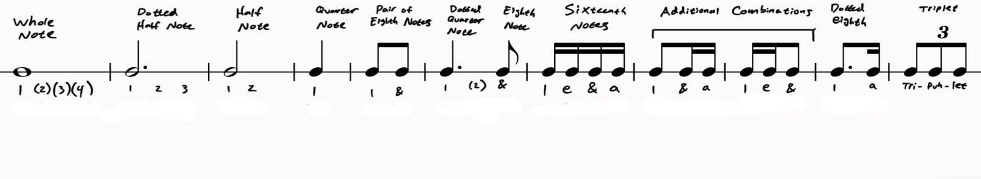

Here is a sample of the sight-reading you would be asked to sight-read. It won’t be this one exactly, but it will be very similar in difficulty. Click here to hear me performing this rhythm.

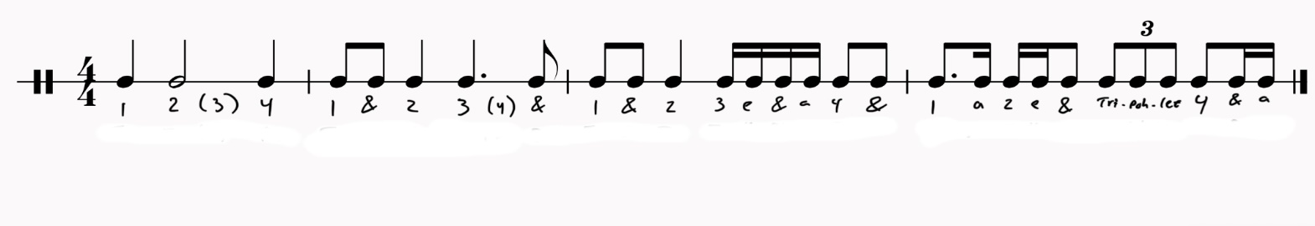

NOTE: You don’t have to perform the rhythm at the tempo you hear in the recording linked above. You can pick whatever tempo, however fast or slow, that you wish. You should do the tempo that allows you to perform the rhythms most accurately and steadily without major pauses between rhythmic units.

Tips for preparing for this portion of the audition:

- Make sure you know how each of the various rhythmic units listed above sounds, feels, and how you might perform them in whatever system you pick.
- Consider signing up for a Sight Reading Factory subscription, in which you can set up custom exercises that exactly mimic the parameters set out above.
- Work on building your sight singing skills with your choir director and/or voice teacher (if applicable)

—-—-—-—-—-—-—-—-—-—-

- Melodic Sight-Reading (~1 minute)

For the melodic sight-reading portion of the audition, you’ll sight-read one (1) melodic passage that is four (4) measures long in 4/4 time. You are welcome to sing the melody in whatever way allows you to be most successful. Common approaches include…

- Solfege (Do Re Mi…)
- Numbers (1 2 3…)
- Neutral Syllable (Tah Tah Tah…)

Below are the parameters you can expect for this portion of the audition:

- Length: 4 measures
- Meter: 4/4
- Keys: C, D, F, or G (major only)
- Rhythms: half notes, quarter notes, eighth notes (pairs)
- Melody: By step, and leaps between Do Mi and So

Tips for preparing for this portion of the audition:

- Practice singing scales in solfege (e.g. DRMFS…), patterns (DMRFMSFL…), and arpeggios (DMSDSMD). Once you’ve internalized those pitch relationships, transferring that knowledge to a piece of sheet music is much easier.
- Use this custom Solfege ID exercise (created by me in musictheory.net) to practice your solfege ID in the keys of C, D, F, and G. (Bass clef folks, click here)
- Consider signing up for a Sight Reading Factory subscription, in which you can set up custom exercises that exactly mimic the parameters set out above.
- Check out the Florida Vocal Association’s history of past sight-reading exams. These are free and cover the level we’re talking about. Practice these a lot. Especially, focus on Middle School LEVEL 3 and High School LEVEL 2; Both of those are roughly around the difficulty you can anticipate for this audition.
- Work on building your sight singing skills with your choir director and/or voice teacher (if applicable)

—-—-—-—-—-—-—-—-—-—-

- Sing Something of Your Choice (30-60 seconds)

For this portion of the audition, you’ll prepare to sing 30-60 seconds of anything you pick. It could be something from voice lessons, something from a choir song you’ve sung in the past, a song you love, etc. Anything! If you’re not sure what to do, no problem, just sing “Happy Birthday,” the National Anthem, or another melody you might know. The goal is for me to hear you sing something you feel confident singing. This can be in any style. Occasionally, I’ve found that some singers' strongest voice is when they are singing a pop song, gospel, or in a rock style. The most important thing is you pick something, anything, that you feel shows off your voice in whatever style your voice feels most comfortable singing. Again, not sure what to do? “Happy Birthday” is perfect. :)

Tips for preparing for this portion of the audition:

- Pick an excerpt of a song you LOVE, that you feel confident singing a cappella, and that shows off your voice. Don’t pick what you think I would like; pick something you love that you can really sing. Plus, I love all kinds of music! This is a great chance to show off a part of your voice that may not be covered in the vocalizes.
- Record yourself singing this excerpt (video is great) – give yourself feedback on your singing, your communication, and your facial expression. This should be a place where you can also demonstrate the way you express music to others.
- Sing for a friend, a family member, or another person so you can get comfortable singing this part for this final short portion of the audition.
- Work on this short excerpt with your choir director and/or voice teacher (if applicable)

ADDITIONAL CONSIDERATIONS

In addition to your audition, a few other elements are factored into the final decisions of ensemble placement. These include…

Spot Availability…sometimes, there are many spots open for a particular voice part, and thus, in that year, more auditionees in that voice part may successfully audition into various ensembles. Likewise, sometimes there may be only a handful of available spots, and thus the competition for those slots is tighter.

Voice Part Balance…when voicing the choirs, I strive to make sure there are roughly equal numbers of singers between each section to ensure a balanced sound between each part. Sometimes I’ll add a few extra extra altos in an SA choir to help ensure the music is well-balanced.

Seniority…in cases when there are two equally strong auditionees being considered for a spot, when possible, I will seek to give that opportunity to the more senior (i.e. older) applicant. However, seniority is only one of the many considerations; if there is a low-scoring audition from a senior that is significantly below where other younger singers may have placed, then seniority will not factor in as strongly. Think of it more like a tie-breaker than the main deciding factor.

A FINAL NOTE

Please know that I do not take these difficult decisions lightly. Regardless of what choir you are placed in, know that you are loved, valued, and above all, brave for auditioning.

I urge all auditionees – and their caregivers – to embody a growth mindset around the audition process and ensemble placement. Bloom where you’re planted and sing with joy with whomever you are honored to sing alongside.

It’s going to be a great year, and again, thank you for auditioning for OYC!

Questions? Please contact us:
jcfallon@gmail.com
oconeeyouthchorale.org

